Skeletal growth problems of the Great Dane
by Dr.Patrizio Donati vet. ( Kennel Della Baia Azzurra-Italy )
http://www.baiaazzurraalani.com/CD.htm

courtesy: permission to reprint by the President of the Doggen Club de France –
M. Jean-Francois Martin

translation : Bernd Völxen

The bone comprises diverse regions of the anatomy.

articular cartilage

epiphysis : this are the tips of the joints of a tubular bone. The bone is porose
and in the process of growth calcination occurs.

diaphysis: this is the intermediate part of the tubular bone in cylindrical shape
covered by the periosteum alike a cortex.

metaphysis: the zone responsible for the growth into length and during the growth
the cartilage is modified into firm bone substance.

The growth of the bone starts with the birth and does not stop during the life time and also with the canides there is a continuous renewal of the periosteum ( bone-skin). The osteoblastes and osteoklastes are responsible for the exchange. Firstly the osteoblastes are responsible for the growth of the bone with the collagen, the mucopolysaccharides ( high polymere hydrocarbons), the calcium and the phosphorous. Secondly the factors to transform dead and live bone cells. Those structures delegate the growth of cartilage.

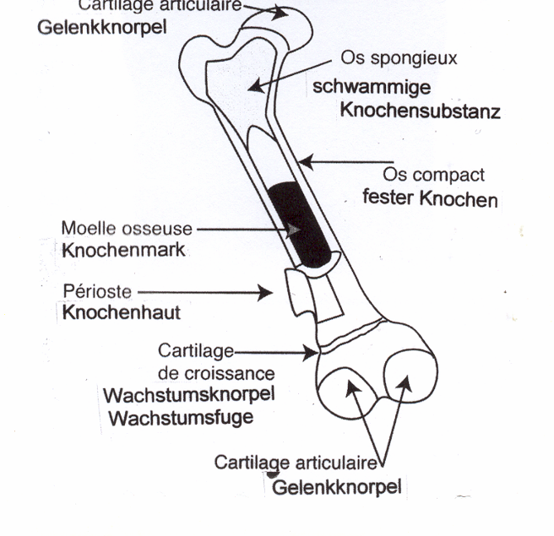
articular
cartilage
articular cartilage
porous
substance
solid bone
periosteum
marrow
growth
cartilage

New cells, that are repsonsible for the growth of the bones are formed between epiphysis and diaphysis . However not all cartilage substances participate in equal importance with the modification of cartilage into bone. The following drawings and the x-ray foto demonstrate the region of the elbow and forearm of a young dog that grows.

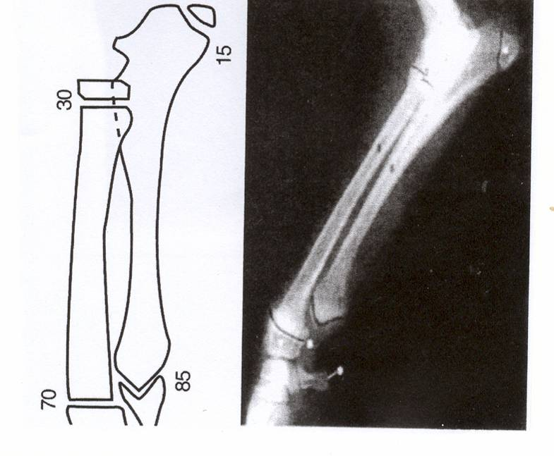

It is not to be understood that whenever the joints of the epiphysis is closed that the growth would stop: the dogs has just reached its growth into length of the bones.Wit the Great Dane the modification of cartilage into bone is terminated by the 11th till 12th month. A premature termination of it may occur when a bitch is in heat, the medication with steroids and /or excessive feeding with minerals (calcium) and vitamin D is made.

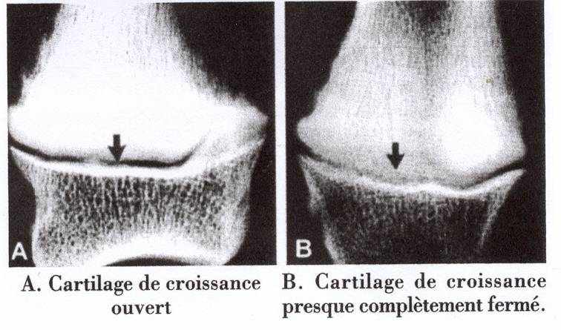

A. cartilage growth joint is open B. cartilage growth is almost terminated

Growth and maturing of a young Great Dane is the result of genetic interaction, enviromental influences and balanced nutrition.
Eventually the genetic aspect may be controlled by the breeder in case he bans genetically imbalanced dogs from breeding. The volume of physical activity of a dog arrives from the climate( temperature) it lives in (environmental factor) and relates to the housing offered by the owner, as well as its health status and diet and are also depending on the cooperation between owner and vet. Many factors of the diet may have a negative influence on the growth of a puppy. Mainly responsible is calcium and the amount of calories in the diet .

Calcium

In principle it does influence the nutrition – for better of worse – and the growth of a puppy. Special attention must be paid towards the feeding of calcium and calories.

As to calcium, its total volume contained in the feedstuff and its relation to the phosphorous content is responsible for most deformation in the skeleton of a Great Dane during its growth.

For the puppy as well as for the adult dog calcium is a vital element that offers an active part in many functions, especially in muscular activities ( hence also for the cardiological functions ), the transfer of nerve impulses and it plays a major role with biochemical reactions and with the metabolism. Without calcium those functions were impossible. In addition the blood needs a constant volume of calcium .
This concentration of calcium in the blood is called “calcemy” and its value is important for a number of physiological procedures. It is controlled by the intestines: the bowel, the bones and the kidneys. Calcium incorporated in nutrition is absorbed in the small intestine. However there is a significant difference between puppy and adult dog.
The adult dog is able to determine according to its needs the volume of calcium to be taken in and eventually absorps physiologically depending on needs. The puppy however takes the whole volume of calcium in that is content of its diet.
Any calcium digested in the bowel will be passed on to the bones and deposited there upon demand. In case the storage capacity in the bones is reached or surpassed the oversupply of calcium results eventually in diseases.

The hormone “parathormone” controls the calcium metabolism via the kidneys and ensures the way out by urination. But in case of oversupply of calcium the kidneys are not in a position to eliminate and pass it out via urination.
Consequently calcium taken in with nutrition cannot be discharged and is deposited in the bones. Hence it becomes responsible for skeletal problems during the growth of the Great Dane.

availability of calories

Breeds of various kinds are fed in many different ways and traditions. Often it is depending on daytime and routine. No other species offers as much as to variety of size, coat etc. This fact should actually lead to the conclusion that each breed needs to be evaluated separately and one has to explain why this or that breed is so special that it would lead to a special diet which is so important for a giant breed such as the Great Dane.
There is a public opinion that dogs of this breed need a different volume of mineral salts and vitamins to grow a nice bone structure.
But whenever a diet is composed one should not only focus on contents of the diet but also on the energy needed. In composing a diet the size , energy demand and weight of the breed needs to be taken into consideration. For instance: a Great Dane with a weight of 50 kgs needs the double rationing as compared to a Labrador Retriever of approx. 25 kgs. But reality shows “it is different”.
Hedhammer constructed a diet with high proteine content in 1974, (Vitamin A and D, Calcium, Phosphorous) for 12 couples of Great Dane Puppies. In each couple one puppy was fed ‘ad libidum’ ( no special rules) – while the other was fed with just 2/3 of this volume. The first group grew rapidly but did not reach a nice body when they were adult age. They had reached an enormous weight but they indicated more lazyness, were timid and had a number of diseases with the bones.
Experiences tells that most of the skeletal problems occur due to oversupply of food. However Rachitis in its traditional form seems to have vanished completely.
There are two parameters vital for the saturation of a dog. First the stomach is stretched as it is too full ( immediate saturation) – Second the saturation is reached after digestion of the food.
Dry feedstuff contains just a minimum of moisture – roughly 10 %. But fresh meat contains about 80% moisture(water) and only 20% dry material ( almost proteins alone).
So in case a puppy is overfed by 100gr of dry feedstuff this means it gets a surplus of 450 gr meat. A pound of meat fills the stomach of a puppy up and gives the saturation feeling at once. Dry feedstuff does not give this immediate feeling of saturation. It was recommendable to give needed and limited volume of food.

The inexperienced owner ( sometimes ill informed) is tempted to select the “best feedstuff”. At the same time industrially made feedstuff with high energy potential is selected and this gives more than double of the needed demand of energy to the puppy. The puppy has to digest a far too big volume of unsuitable food. Both types of feedstuff contain a large content of calcium and will lead to oversupply of calcium.

In the past dogs were fed “off the table” and insufficiencies often occurred. Nowodays the feedstuff is balanced but regrettably often it is given in wrong volumes ( too much) and unsuitable as it leads to diseases that are caused by overfeeding. To reach a proper growth the volume needs to be adjusted, bearing in mind the growth curve that is ideal for the relevant breed.

There is a fundamental rule: “hands off from any supplementary diet”

This introduction should be seen as guide for preventive feeding, to avoid a diet that is an oversupply of proteins and calories, vitamins and minerals and it will enable to trace growth problems quickly in order to interfere and correct and hence avoid massive defects. Here are again the significant symptoms:

- lethargy – lazyness
- apathy – slow moving
- pain in the extremities
- overweight puppies, sluggish in joints
- incorrect stack
- swollen joints (visible as out-of-size joints)

premature closing of ulna and radius at the growth joint

As already explained the cartilage joints have the target to build bones, primarily the mataphysis where the cartilage modifies into bone structure and determines the growth of the length of the bones. The cartilage joint however will be damaged in case biomechanical forces create excessive pressure that will provoke degenerative effects and provide structural anomalies. Pressure leads to thickening of the cartilage and prevents the modification of cartilage material into bone structure. One of the main issue is overweight that leads to pressure and creates a constant damage of the growth joints.of the extremties. Should the pressure fade a normal growth activity is reactivated but it still leads to a temporarily slow down in the growth of the tubular bones. A damage – despite little – will occur and lead to a deformation of the angulation. In case the slow down of the growth occurs only with the long tubular bone ( ulna – radius) a signifant deformation of the bones becomes apparent.

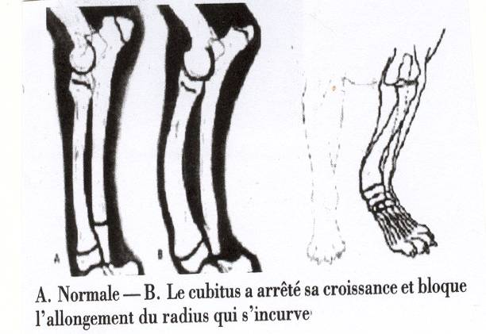
A. Normal - B. the ulna stopped the growth and blocks the length growth of
the radius – which forms a curve

The persistent pressure – or call it the unexpected damage – usually cause a premature closing of the cartilage joints. The diagnosis is a shortening of the extremities, that become very much visible as the dog is still very young, when those deformations occur.

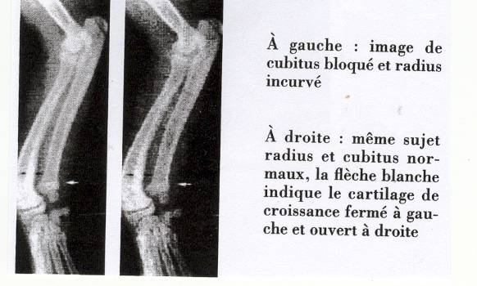
left picture: the curved radius caused by a blocked ulna
right pricture: same dog with a normal ulna and radius. The white indicator
refers to the closed cartilage joint left – while open at right

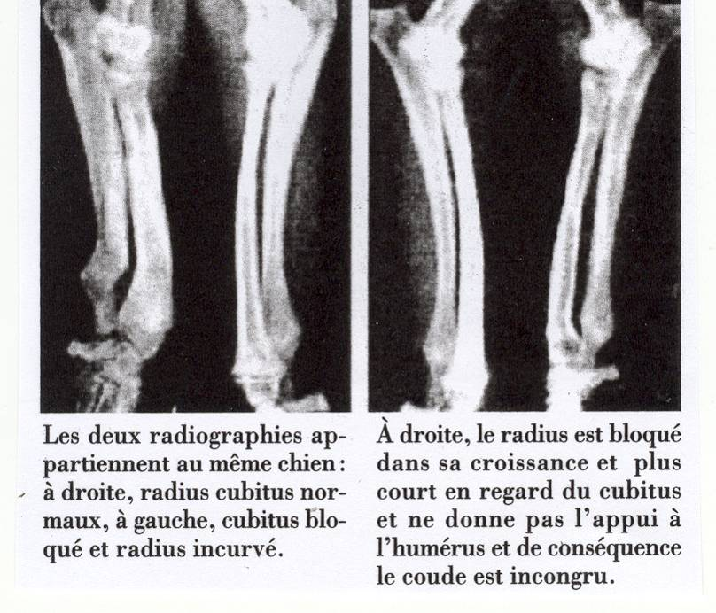
those fotos above show the same dog.

foto left: at right normal ulna and radius foto right: the radius is blocked and much shorter
at left ulna blocked and radius curved than the ulna, hence the upper arm has no firm
position ( incongruency)

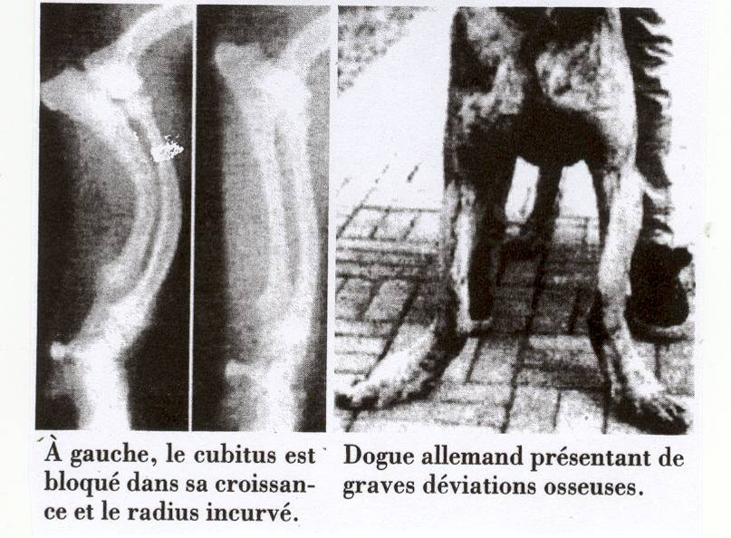

foto left: the ulna is blocked and the radius is curved
foto right: this great dane has extreme deformations

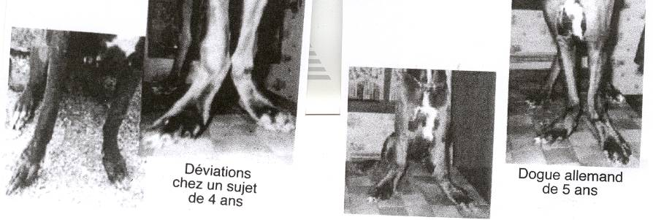

deformation with a 4 year old Great Dane of 5 years

Osteosarcome

Osteosarcomes are the most frequent malign skeletal tumors with dogs and represent 80-85% of the bone tumors. Mainly large breeds are effected ( St.Bernhard, Great Danes, Boxeers, German Shepard Dogs and English Setters ). The risk to meet this disease is about 60-85% higher as compared to smaller breeds.
The age of the sick dogs is between 10 and 18 months ( medium age reached 7 ½ )
while dogs suffer with a share of 55 % as compared to bitches with 45% .

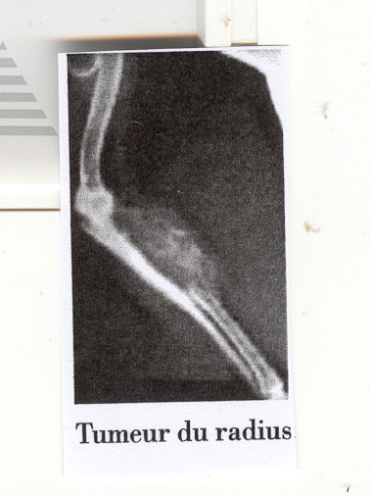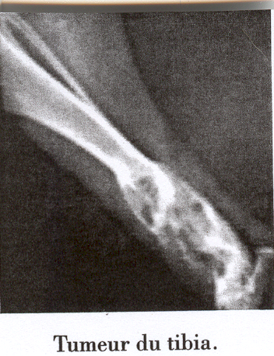

tumor at the radius tumor at the tibia

According to a study of Liu together with his students, which was carried out on 183 dogs being sick of osteosarcoms the following diagnosis was found: 20 % thigh-bones, 19.5% forearm, 19.2% radius, 9.3% tibia, 7.6% scull, 6.5% vertebrael bones, 4.9% ribs, 4.4% clavicular bones, 4.4% elbow, 3.3% pelvis and 2.2% metacarpal bones.

Buraco has stated that osteosarcomes with dogs are mainly found in the front extremities – 47%- while in the rear it was 29% and scull and lower jawbones 11% - miscellaneous 13%.
The causes for the growth of bone tumors are largely unknown. Skeletal deformations, foreign bodies, rays, onkogenetic cells that may be activated to become tumorous, viral infections and genetic disposition. Those are the main reasons for tumors to appear, surely are responsible for deformation and skeletal diseases that resemble bone tumors. With humans it is more likely a sort of recessive bone growth or damages at the vertebrael disks that may develop into chondrosarcoma (malign tumor of cartilage tissue) at about 5- 11% of the patients.
Most of the osteaosarcomes appear in zones of the tubular bones where the growth of length and active cellular growth occurs. With dogs it is the region of the growth gap (radio – distal = distant of the body midst ) and humerus proximal ( = upper extremities and angulation)
In most cases where large breeds suffer from osteosarcomes this occurs due to the enormous pressure that rests on the frontal extremities. The confirmation of this hypothesis arrives due to the fact that with small breeds the osteosarcomes appear at much different locations of the skeleton.

to be continued……

